# Media Analysis - Will ChatGPT and AI have an impact on Saudi workforce productivity_ _ Arab News

## Short Summary

The article is about how ChatGPT and AI are expected to impact the Saudi workforce productivity by automating mundane tasks, providing tailor-made training programs, and reshaping various sectors like healthcare, transportation, energy, finance, and retail.

## Summary

1. ChatGPT and AI can boost productivity in Saudi Arabia by providing tailor-made training programs, access to customized online courses, and fostering collaboration among team members.  
2. Embedding AI into operations requires a holistic approach that defines strategic objectives, advantages, and disadvantages. Understanding operational bottlenecks and how AI can address them is crucial.  
3. The automation of tasks by ChatGPT may lead to job displacement for employees entrusted with mundane and repetitive tasks, necessitating retraining or upskilling for workers.  
4. A positive employee and client experience is vital when implementing AI. Leadership, a futuristic view, and agility in making timely changes are essential for successful integration of AI into organizations.

## Question 1

In the given text, the media frames the public discussion about ChatGPT and AI in general as a tool for boosting productivity and economic development. The metaphor of a wave of change is used to describe the impact of these technologies on the global workforce. Another recurring metaphor is that of an opportunity for organizations and employees to innovate, learn, collaborate, and improve their skills to adapt to an AI-enabled digital world. The text also refers to AI as a tool that can help automate mundane and repetitive tasks to free up time for strategic activities, using the metaphor of a productive and efficient workforce. However, there is also a concern about job displacement due to automation, which is depicted as a potential negative side effect. Overall, the text presents AI, particularly ChatGPT, as a transformative technology that can reshape and emancipate the Saudi workforce, but requires careful management and strategic planning to ensure positive outcomes.

## Question 2

Perspectives and aspects that are being widely covered in this text include 1. The positive impact of AI technologies such as ChatGPT on Saudi Arabian workforce productivity. 2. Fear among workers about losing their jobs due to AI, and efforts to alleviate these fears by nurturing the right talent with a strong AI culture. 3. The role of AI in various sectors such as healthcare, transportation, energy, finance, and retail. 4. The benefits of AI for recruitment, hiring, training, development, upskilling, reskilling, talent collaboration, and knowledge management. 5. The potential of AI to increase productivity by automating mundane tasks and freeing up employees to focus on strategic activities. 6. The need to create a positive employee experience through understanding the strategic objectives, advantages, and disadvantages of AI implementation. 7. The importance of leadership, agility, and an optimistic environment for learning and improvement in embedding AI into organizations. 8. The potential impact of AI on Saudi Arabia s public sector operations and service delivery. 9. The concerns about the stability of worker employment due to automation. 10. The need for employees to acquire new skills through retraining or upskilling to remain marketable in an increasingly digital world. Aspects that are being ignored in this text include 1. The specific challenges faced by Saudi Arabia in implementing AI technologies, such as infrastructure limitations, regulatory constraints, or cultural resistance. 2. The ethical considerations related to the use of AI, including issues of data privacy, bias, and accountability. 3. The potential negative consequences of widespread AI adoption on employment, income distribution, and social inequality. 4. The environmental impact of AI technologies, such as energy consumption, e-waste generation, or resource depletion. 5. The potential risks associated with over-reliance on AI, such as algorithmic failures, cybersecurity threats, or dependence on a single vendor. 6. The need for continuous monitoring and evaluation of AI systems to ensure their performance remains optimal and aligned with strategic goals. 7. The need for international cooperation in the development and regulation of AI technologies to prevent a digital divide between developed and developing countries.

## Question 3

Not mentioned

## Question 4

The article suggests that AI, specifically ChatGPT, can positively impact Saudi workforce productivity by providing customized training programs, collaboration tools, and automating mundane tasks. However, it also warns about potential job displacement due to automation. Embedding AI requires a holistic approach, clear strategic objectives, understanding of operational bottlenecks, and fostering an optimistic learning environment. Leadership, agility, and a futuristic view are crucial for successful implementation.

## Sentiment

The sentiment is 3.0

## Entities

Embedding AI, Arthur D. Little, Saudi Arabias, Kingdoms, Kaspersky, Arab News, Raymond Khoury, Khoury, AI, Khourys, Kasperskys, Arthur D. Little

## Highlights

#7cc867#fb5b89#f9cd59#c885da

## Wordcloud for #7cc867 Highlights

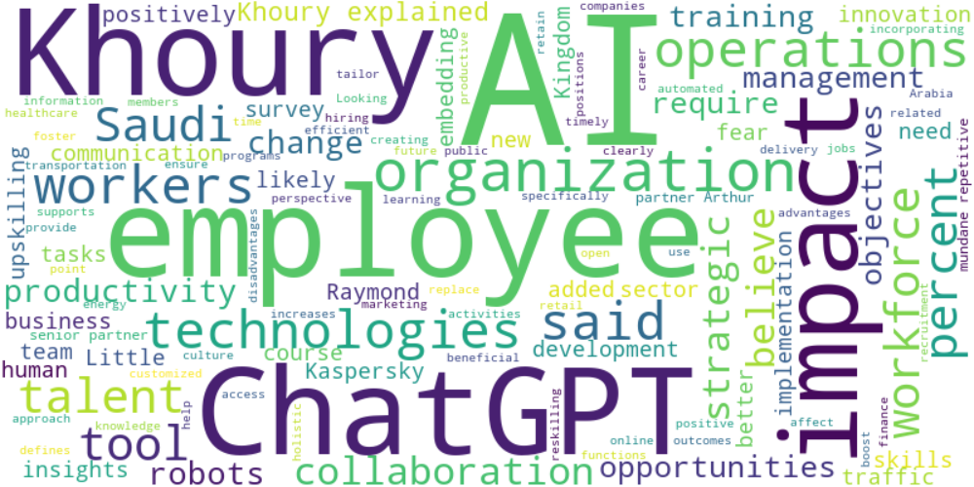

Top 10 words:

- AI: 35

- Khoury: 16

- ChatGPT: 12

- employees: 11

- impact: 9

- technologies: 6

- operations: 6

- said: 6

- workers: 6

- Saudi: 5

## Wordcloud for #fb5b89 Highlights

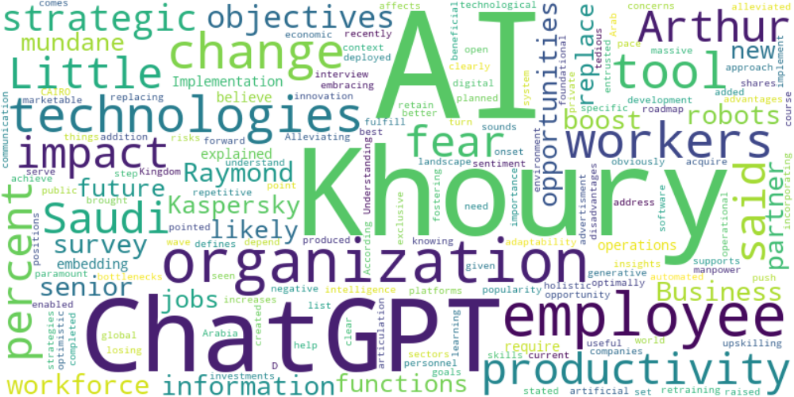

Top 10 words:

- AI: 14

- Khoury: 9

- ChatGPT: 6

- employees: 5

- technologies: 4

- workers: 4

- impact: 3

- Saudi: 3

- productivity: 3

- Arthur: 3

## Wordcloud for #f9cd59 Highlights

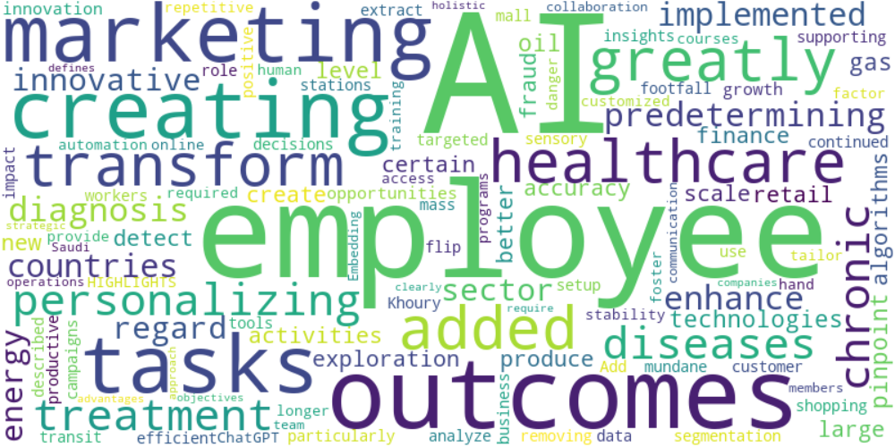

Top 10 words:

- AI: 7

- employees: 3

- outcomes: 2

- marketing: 2

- creating: 2

- tasks: 2

- added: 1

- greatly: 1

- transform: 1

- healthcare: 1

## Wordcloud for #c885da Highlights

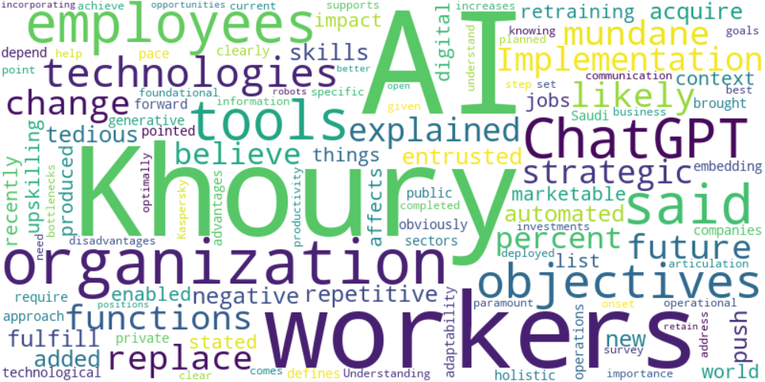

Top 10 words:

- AI: 8

- Khoury: 6

- workers: 4

- ChatGPT: 3

- said: 3

- tools: 3

- employees: 3

- objectives: 3

- organization: 3

- technologies: 3